SUPPORTING INFORMATION

Vocal behavior of the Undulated Tinamou (Crypturellus undulatus) over an annual cycle in the Brazilian Pantanal: new ecological information

Cristian Pérez-Granados^{1,2*}, Karl-L. Schuchmann^{1,2,3} & Marinez I. Marques^{1,2,4}

¹ National Institute for Science and Technology in Wetlands (INAU), Federal University of Mato Grosso (UFMT), Computational Bioacoustics Research Unit (CO.BRA), Fernando Correa da Costa Av. 2367, Cuiaba, MT 78060-900, Brazil.
² Postgraduate Program in Zoology, Institute of Biosciences, Federal University of Mato Grosso.
³ Zoological Research Museum A. Koenig (ZFMK), Ornithology, Adenauerallee 160, Bonn 53113, Germany.
⁴ Postgraduate Program in Ecology and Biodiversity Conservation, Institute of Biosciences, Federal University of Mato Grosso.

* Corresponding author: Cristian Pérez-Granados perezgranadosc@hotmail.com

FIGURE S1. Locations of the four acoustic monitoring stations in Pantanal Matogrossense (Poconé municipality, Mato Grosso, Brazil). The inset shows the location of the study area (star) in Brazil. The Cuiabá River is shown in the lower right corner of the image. The image was extracted from Google Earth on 31 March 2016. Scale bar: 2 km.

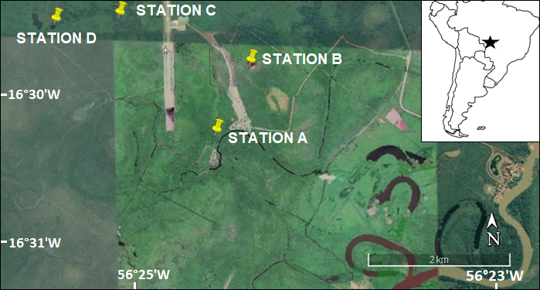

FIGURE S2. Results of the Tukey post-hoc test for the factor Hour. Different letters mean significant differences in the calling activity (% of calls) between hours after Tukey test.
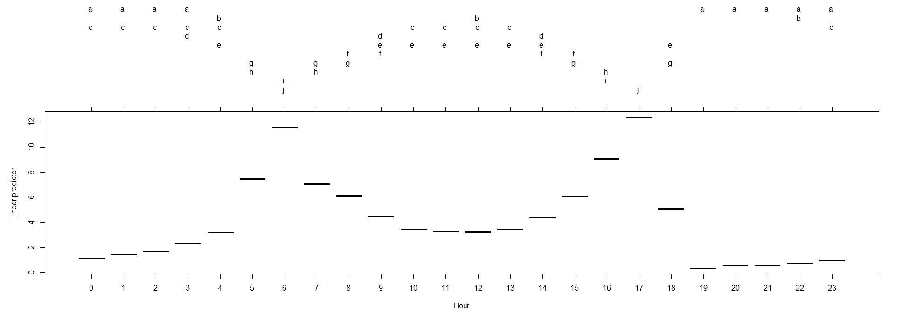

FIGURE S3. Results of the Tukey post-hoc test for the factor Month. Different letters mean significant differences in the calling activity (number of calls) between months after Tukey test.
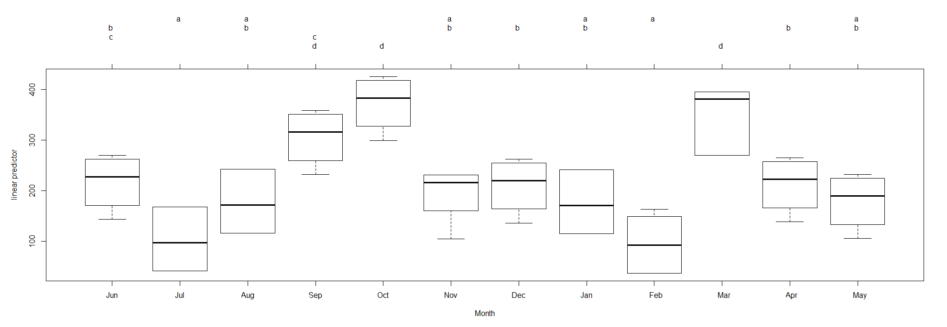

TABLE S1. Mean (and range) of the acoustical parameters of the call of the Undulated Tinamou in Pantanal Matogrossense (Brazil). A total of 52 calls from eight different recordings (two from each acoustic monitoring station) were measured. Recordings were collected using a Song Meter SM2 recorder (Wildlife Acoustics), and call measurements were made using Raven Pro 1.5. Intersyllable gap refers to the time lapse between the first and second syllable.
Minimum Frequency (Hz) | Maximum Frequency (Hz) | Dominant Frequency (Hz) | Duration (s) | Intersyllable gap (s)
1042.0  (944.8 – 1090.2) | 1476.0  (1421.3 – 1548.9) | 1279.5  (1218.8 – 1312.5) | 1.70  (1.49 – 2.00) | 0.27  (0.14 – 0.42)

TABLE S2. Number of detections and number of Undulated Tinamou calls detected by Kaleidoscope Pro 5.1.8 employing variable distances from the cluster center. For this analysis we randomly selected 674 15-min length recordings made between August and September 2015 from our dataset. We introduced the following signal parameters in Kaleidoscope: minimum and maximum frequencies of 1,150 and 1,350 Hz, respectively, minimum and maximum detection durations of 1.3 and 3 s (to include overlapping signals and birds duetting), respectively, and a maximum intersyllable gap of 0.6 ms. The total number of events and calls detected are shown separately for each distance from the cluster center. The detector accuracy, estimated as the number of tinamou calls divided by the total number of events detected, is also shown.

Distance from the cluster center | Detections | Tinamou calls | Accuracy (%)
0 | Not run | Not run | Not run
0.1 | Not run | Not run | Not run
0.2 | 115 | 103 | 89.6
0.5 | 11,445 | 6,218 | 54.3
0.75 | 18,444 | 9,538 | 51.7
1 | 19,845 | 9,835 | 49.6
1.5 | 19,928 | 9,896 | 49.7
2 | 19,930 | 9,896 | 49.7

TABLE S3. Number of monitoring days, number of days in which the Undulated Tinamou was detected and total number of Undulated Tinamou calls detected per station in Pantanal Matogrossense (Brazil). Calling activity was monitored by acoustic monitoring from 8 June 2015 to 31 May 2016 (359 days) at four acoustic monitoring stations.

 | Monitoring days | Days detected | Total of calls
Station A | 354 | 354 | 70,863
Station B | 344 | 344 | 95,715
Station C | 329 | 329 | 87,915
Station D | 355 | 353 | 51,088
TOTAL | 1382 | 1380 | 305,581

TABLE S4. Daily mean number of Undulated Tinamou calls detected per hour at four monitoring stations in Pantanal Matogrossense (Brazil). The total number of calls detected per hour is also shown. Calling activity was monitored by acoustic monitoring from 8 June 2015 to 31 May 2016 at four acoustic recording stations.
Hour | Station A | Station B | Station C | Station D | Mean | Total
0 | 0.66 | 2.25 | 0.85 | 1.26 | 1.25 | 4,011
1 | 0.81 | 2.62 | 1.43 | 1.77 | 1.66 | 5,247
2 | 0.87 | 2.75 | 1.58 | 2.27 | 1.87 | 5,792
3 | 1.00 | 3.55 | 2.38 | 3.47 | 2.60 | 7,970
4 | 0.89 | 4.13 | 3.11 | 5.07 | 3.30 | 9,906
5 | 5.34 | 9.35 | 8.91 | 7.62 | 7.81 | 24,461
6 | 9.43 | 10.14 | 9.81 | 11.39 | 10.19 | 30,822
7 | 5.68 | 4.95 | 4.89 | 9.83 | 6.34 | 18,087
8 | 5.51 | 4.41 | 4.89 | 7.86 | 5.67 | 16,452
9 | 4.43 | 3.30 | 4.32 | 6.18 | 4.56 | 13,250
10 | 4.52 | 2.32 | 4.04 | 4.40 | 3.82 | 11,220
11 | 5.46 | 2.49 | 3.66 | 3.61 | 3.80 | 11,305
12 | 5.31 | 2.31 | 3.69 | 3.20 | 3.63 | 10,847
13 | 4.73 | 3.44 | 4.23 | 3.02 | 3.85 | 11,899
14 | 6.22 | 3.96 | 5.30 | 3.64 | 4.78 | 14,724
15 | 8.19 | 5.40 | 6.34 | 5.41 | 6.33 | 19,306
16 | 13.04 | 9.05 | 9.18 | 5.96 | 9.31 | 29,019
17 | 13.94 | 13.17 | 12.60 | 8.01 | 11.93 | 37,657
18 | 3.24 | 4.44 | 5.53 | 2.50 | 3.93 | 12,676
19 | 0.01 | 0.45 | 0.43 | 0.44 | 0.33 | 1,028
20 | 0.09 | 1.20 | 0.61 | 0.59 | 0.62 | 2,042
21 | 0.12 | 1.02 | 0.54 | 0.67 | 0.59 | 1,875
22 | 0.22 | 1.30 | 0.77 | 0.81 | 0.78 | 2,492
23 | 0.31 | 2.00 | 0.94 | 1.03 | 1.07 | 3,493

TABLE S5. Daily mean number of Undulated Tinamou calls detected per month and station in Pantanal Matogrossense (Brazil). The monthly percentage of calls detected per month, with respect to the total number of calls, is also shown. Calling activity was monitored by acoustic monitoring from 8 June 2015 to 31 May 2016 at four acoustic monitoring stations.
Month | Station A | Station B | Station C | Station D | Total | %
June 2015 | 113.8 | 215.2 | 123.0 | 414.6 | 216.6 | 8.3
July 2015 | 78.1 | 101.3 | 96.7 | 165.8 | 111.7 | 4.3
August 2015 | 91.8 | 255.7 | 135.7 | 269.1 | 189.0 | 7.3
September 2015 | 164.1 | 448.4 | 388.2 | 220.6 | 305.3 | 11.7
October 2015 | 297.4 | 673.6 | 415.7 | 103.9 | 372.7 | 14.3
November 2015 | 182.2 | 229.4 | 257.3 | 40.4 | 178.5 | 6.9
December 2015 | 179.5 | 371.8 | 257.1 | 29.0 | 209.3 | 8.1
January 2016 | 155.5 | 339.6 | 248.3 | 12.0 | 187.4 | 7.2
February 2016 | 207.0 | 46.4 | 94.9 | 10.3 | 94.7 | 3.6
March 2016 | 475.1 | 260.3 | 529.4 | 116.2 | 343.1 | 13.2
April 2016 | 250.8 | 155.5 | 234.9 | 206.2 | 211.8 | 8.2
May 2016 | 202.4 | 98.1 | 231.1 | 184.2 | 178.9 | 6.9
TOTAL | 200.2 | 278.2 | 267.2 | 143.1 | 220.8 | 100

